BLOOD BANK MANAGEMENT SYSTEM

PROJECT TITLE :
Blood Bank Management System
PROJECT OVERVIEW :
The Blood Bank Management System helps manage blood donors, blood inventory, blood requests, and blood donations efficiently. It allows blood bank staff to maintain records digitally instead of using manual registers.
PROBLEM STATEMENT :
Many blood banks maintain donor and blood stock records manually, which can lead to:
- Data redundancy
- Difficulty in tracking blood availability
- Delayed response to blood requests
- Errors in donor information management
This system automates the management of blood bank operations.

TECHNOLOGIES USED :

FRONTEND :
- HTML
- CSS
- Bootstrap
- React.js

BACKEND :
- Java
- Spring Boot

DATABASE :
- PostgreSQL

PROJECT OBJECTIVES :
The main objective of the Blood Bank Management System is to develop a web-based application that automates and simplifies the management of blood bank operations, including donor records, blood inventory, donations, and blood requests.

SPECIFIC OBJECTIVES :
1.To maintain donor information efficiently
Store and manage donor details such as name, blood group, contact information, and donation history.
2.To manage blood inventory effectively
Track available blood units of different blood groups and maintain accurate stock records.
3.To record and monitor blood donations
Maintain donation records and update blood stock automatically after successful donations.
4.To process blood requests quickly
Enable staff to create, update, and track blood requests from hospitals or patients.
5.To provide blood availability search
Allow users to check the availability of blood units based on blood groups.
6.To reduce manual paperwork
Replace traditional record-keeping methods with a centralized digital system.
7.To improve data accuracy and reliability
Minimize human errors, duplicate records, and data loss through computerized management.
8.To support efficient decision-making
Provide dashboards and reports that help staff monitor blood stock and donation activities.
9.To implement CRUD operations
Enable Create, Read, Update, and Delete operations for donors, blood inventory, donations, and blood requests.
10.To develop a user-friendly web application
Build an intuitive and responsive interface using React and Bootstrap for easy system usage.

OVERALL OBJECTIVE :
To design and develop a secure, efficient, and user-friendly Blood Bank Management System that automates blood bank operations, improves blood inventory management, and ensures timely access to blood-related information through a web-based platform.

USER AND MODULE IDENTIFICATION :

1. USER IDENTIFICATION :
The Blood Bank Management System will have the following users:
Admin
- Manages the entire system.
- Maintains donor records.
- Monitors blood inventory.
- Handles blood requests.
- Generates reports.

Staff
- Registers donors.
- Updates blood stock details.
- Records blood donations.
- Processes blood requests.

MODULE IDENTIFICATION :

Module 1: User Authentication
- Login
- Logout
- Session Management

Module 2: Donor Management
- Add Donor
- View Donor Details
- Update Donor Information
- Delete Donor Record
- Search Donor by Blood Group

Module 3: Blood Inventory Management
- Add Blood Units
- View Available Blood Stock
- Update Blood Stock
- Remove Expired Blood Units
- Search Blood Availability

Module 4: Donation Management
- Record Blood Donation
- View Donation History
- Update Donation Details
- Delete Donation Record

Module 5: Blood Request Management
- Create Blood Request
- View Requests
- Update Request Status
- Delete Request
- Approve or Reject Requests

Module 6: Dashboard
- Display Total Donors
- Display Available Blood Units
- Display Total Donations
- Display Pending Requests
- Show Quick Statistics

Module 7: Reports Management
- Generate Donor Reports
- Generate Blood Stock Reports
- Generate Donation Reports
- Generate Blood Request Reports
USE CASE DIAGRAM :
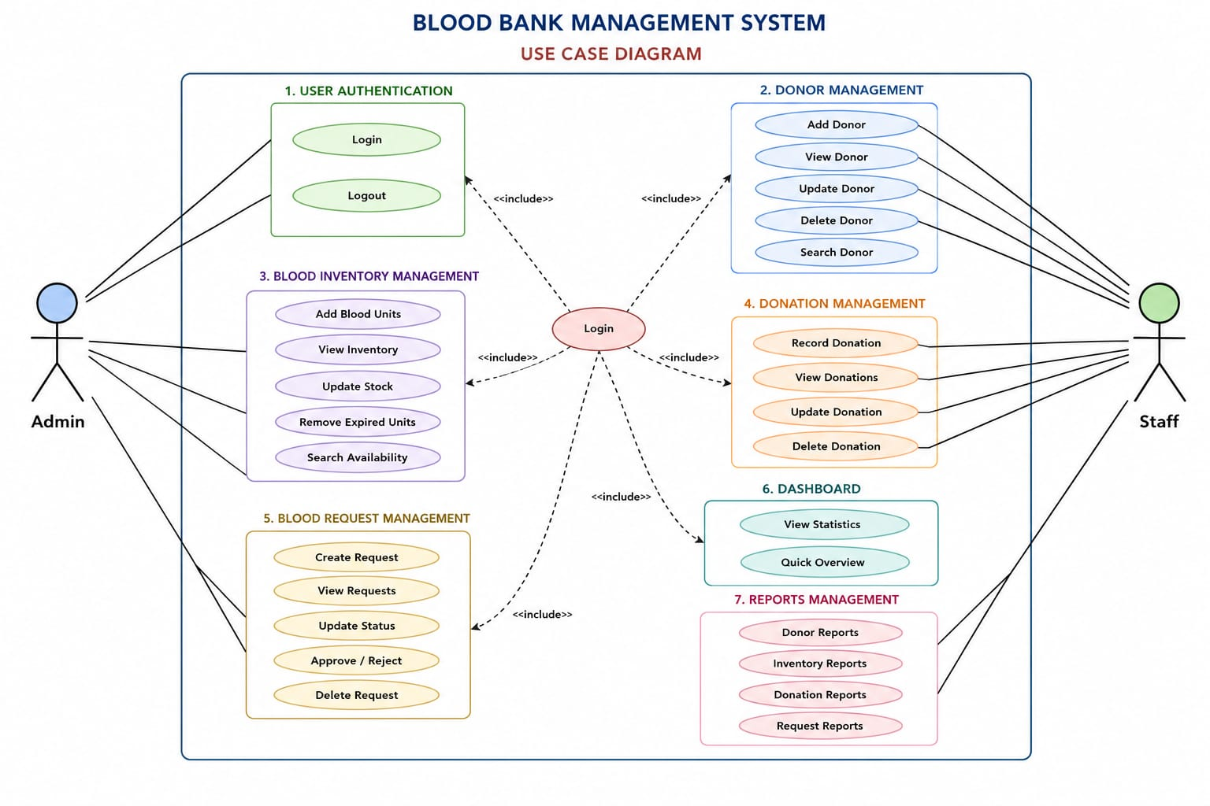
DATABASE REQUIREMENT ANALYSIS :
Table No. | Table Name | Purpose
1. | Users | Stores login credentials and user roles
2. | Donors | Stores donor information
3. | Blood_Inventory | Stores available blood stock details
4. | Donations | Stores blood donation records
5. | Blood_Requests | Stores blood request details
6. | Reports (Optional) | Stores generated report details

Table 1: Users : Stores user authentication and authorization details.

Attributes
- User_ID (Primary Key)
- Username
- Password
- Role (Admin/Staff)
- Email

Table 2: Donors : Stores donor personal and blood-related information.

Attributes
- Donor_ID (Primary Key)
- Donor_Name
- Age
- Gender
- Blood_Group
- Phone_Number
- Address
- Last_Donation_Date

Table 3: Blood_Inventory : Stores available blood stock information.

Attributes
- Inventory_ID (Primary Key)
- Blood_Group
- Available_Units
- Collection_Date
- Expiry_Date

Table 4: Donations : Stores blood donation records.

Attributes
- Donation_ID (Primary Key)
- Donor_ID (Foreign Key)
- Blood_Group
- Units_Donated
- Donation_Date

Table 5: Blood_Requests : Stores blood requests from hospitals or patients.

Attributes
- Request_ID (Primary Key)
- Patient_Name
- Blood_Group_Required
- Units_Required
- Request_Date
- Status
- Hospital_ID (Foreign Key)

Table 6: Reports (Optional) : Stores generated report information.

Attributes
- Report_ID (Primary Key)
- Report_Type
- Generated_Date
- Generated_By

ER DIAGRAM : 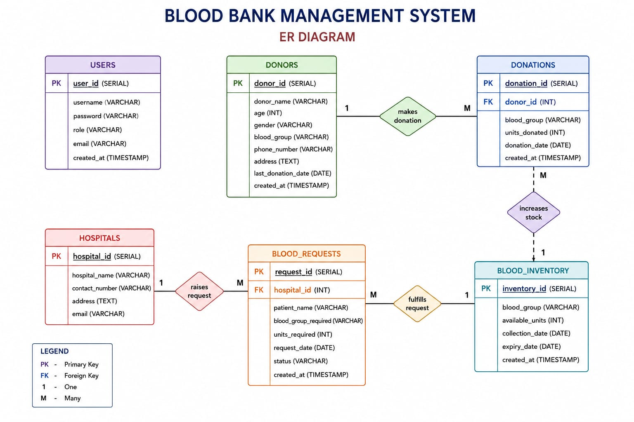

DATABASE SQL SCHEMA CREATION :

TABLE 1 : USERS (ADMIN/STAFF)
CREATE TABLE Users (
User_ID BIGINT AUTO_INCREMENT PRIMARY KEY,
Username VARCHAR(50) NOT NULL UNIQUE,
Password VARCHAR(255) NOT NULL,
Role VARCHAR(20) NOT NULL,
Email VARCHAR(100) NOT NULL UNIQUE
);

TABLE 2 : DONORS

CREATE TABLE Donors (
Donor_ID BIGINT AUTO_INCREMENT PRIMARY KEY,
Donor_Name VARCHAR(100) NOT NULL,
Age INT,
Gender VARCHAR(10),
Blood_Group VARCHAR(5),
Phone_Number VARCHAR(15),
Address VARCHAR(255)
);

TABLE 3 : BLOOD_INVENTORY

CREATE TABLE blood_inventory (
inventory_id SERIAL PRIMARY KEY,
blood_group VARCHAR(5) UNIQUE,
units_available INT,
last_updated DATE,
status VARCHAR(20)
);

TABLE 4 : DONATIONS

CREATE TABLE donations (
donation_id SERIAL PRIMARY KEY,
donor_name VARCHAR(100),
age INT,
blood_group VARCHAR(10),
units_donated INT,
donation_date DATE,
hospital_camp VARCHAR(100)
);

TABLE 5 : BLOOD_REQUESTS

CREATE TABLE blood_requests (
request_id SERIAL PRIMARY KEY,
patient_name VARCHAR(100),
hospital_name VARCHAR(100),
blood_group VARCHAR(10),
units_required INT,
request_date DATE,
status VARCHAR(20)
);

TABLE 6 : REPORTS

CREATE TABLE Reports (
Report_ID BIGINT AUTO_INCREMENT PRIMARY KEY,
Report_Type VARCHAR(50) NOT NULL,
Generated_Date DATETIME DEFAULT CURRENT_TIMESTAMP,
Generated_By VARCHAR(100)
);

This is the required database SQL schema for Blood Bank Management System .

